Ph.D. Comprehensive Examination on Algebra — Spring 2003

Instructions
You have three hours to complete this exam. Please write your solutions in a clear and concise fashion.

Complete each of the following problems
- Let $F$ be a field and $p(x)$ be a polynomial in $F[x]$. Show that the ideal $(p(x))$ in $F[x]$ is maximal if and only if $p(x)$ is irreducible over $F$.
- State the three Sylow theorems. Prove that there are no simple groups of order 182.
- Compute the Galois group of $x^{4}-2$ over $Q$.
- Let $G$ be a finite group and $H$ be a subgroup of $G$. Prove that $G$ is solvable if and only if $H$ is solvable and $G/H$ is solvable.
- Prove the Cayley Hamilton Theorem: every square matrix satisfies its characteristic polynomial.
- Let $A$ and $B$ be two $n×n$ matrices with the property that $AB=BA$. Suppose that $A$ and $B$ are diagonalizable. Prove that $A$ and $B$ are simultaneously diagonalizable.
- Let $R$ be a ring with the following commutative diagram of $R$-modules with each row representing a short exact sequence of $R$-modules and all maps being $R$-module homomorphisms.
- 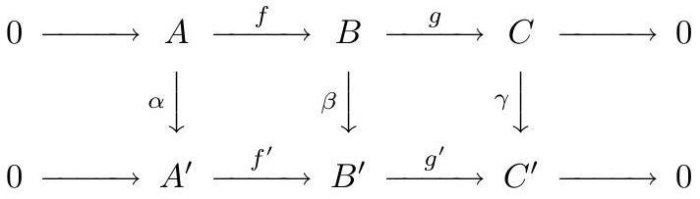
- Commutative diagram for Problem 7.
- Prove that if $α$ and $γ$ are injective maps then $β$ is injective.
- A commutative ring $R$ is Noetherian if and only if it satisfies the ascending chain condition on ideals. Prove that $R$ is Noetherian if and only if every ideal of $R$ is finitely generated.

